DATABASE

MANAGEMENT

SYSTEMS DESIGN

By : Saksham Jain

**Part 1:**

**Install TPC-H database (https://www.tpc.org/tpch/) in your local computer/laptop and use scale factor s= 0.001. Provide detailed instructions, as well as the reasons for using those instructions with screenshots of how you installed TPCH on your computer. (30 points)**

**You need to create the 8 tables given in TPCH. (1 point) Write down the primary key and foreign key of each table. (1 points)**

**Let’s First download the TPCH dataset**

**Steps to download TPC-H are as follows :**

Step 1 : Copy the TPC-H link given in the assignment sheet. TPC website will open. Step 2 : Go to the Downloads tab in the website and select TPC-H Version 3.0.1. As shown in the image below.

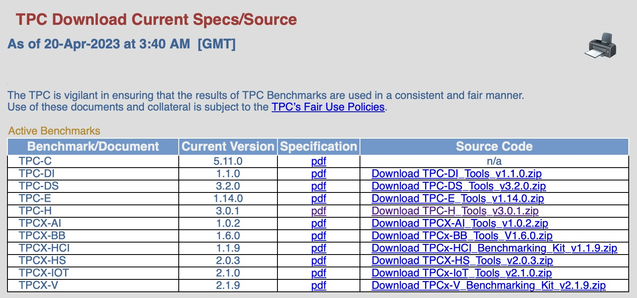

Step 3 : As shown below, this tab will open. Kindly fill details. We will receive an email containing the link to download the tools. The link is an one time useable only and valid for a limited period of time. You will get a zip file from this link, download that zip file by clicking on it.

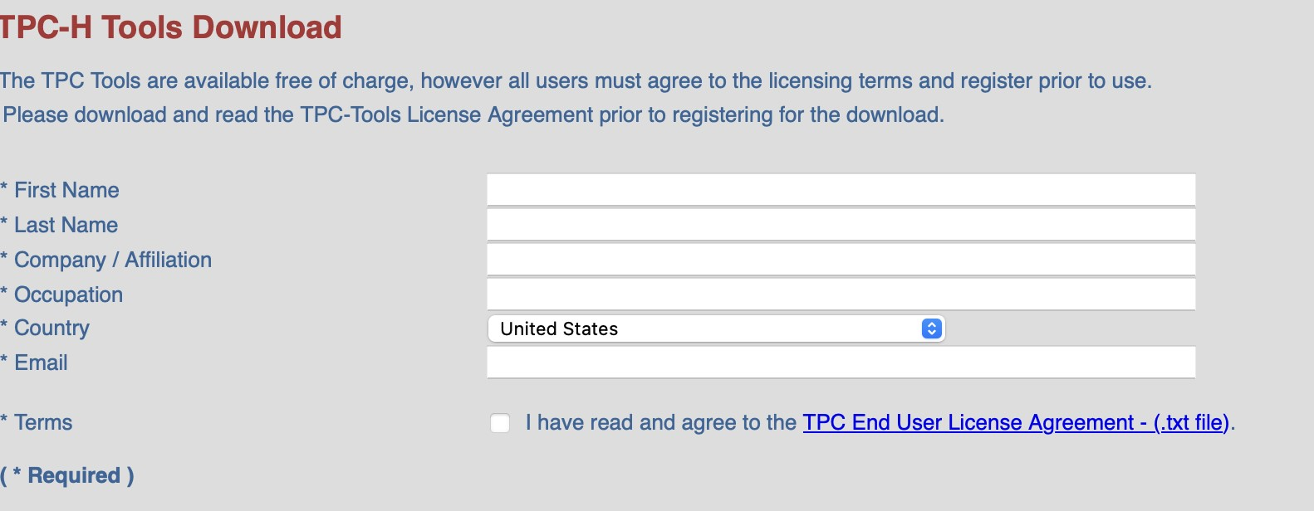

Step 4 : As shown below, this tab will open. Click on the link and the TPC-H zip file will be downloaded to your laptop.

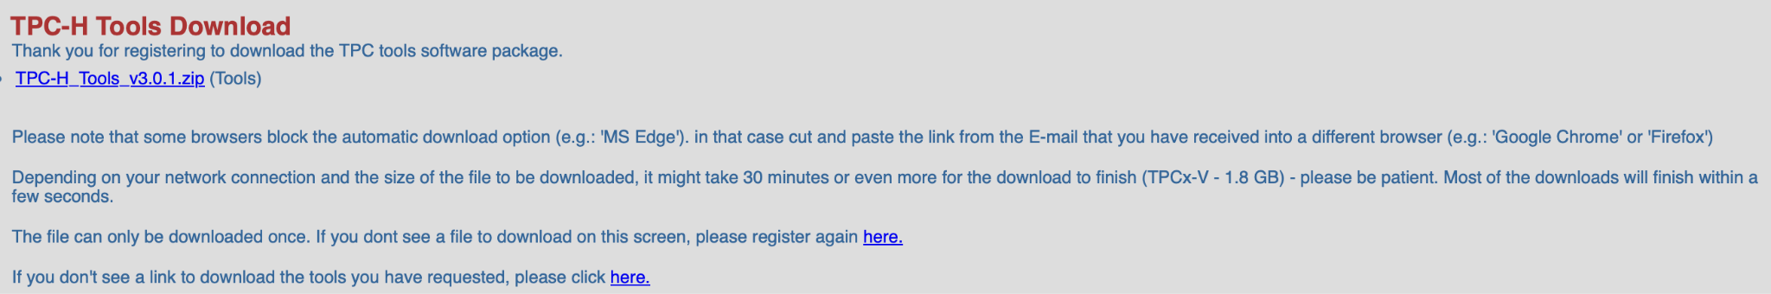

Step 5 : Now open Command prompt (terminal for mac OS). In terminal window, browse to the folder having TPC-H zip file.

Step 6 : As shown below, using ‘cd’ command, we have pointed to dbgen file inside TPCH. Now see all the files inside zip file using ‘ls’ command.

Step 7 : Now we copy and rename makefile.suite

Command : **cp makefile.suite makefile**

I’m using MAC and for database I’m using MYSQL so below are the values I added in the file. **CC = gcc DATABASE =SQLSERVER**

**MACHINE = LINUX**

**WORKLOAD = TPCH**

After making the changes save it and on the terminal run the command “make”.

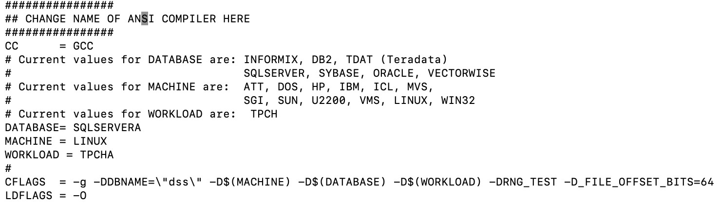

Step 8 : We have used command “**nano**”. Command nano is an easy to use command line text editor for Linux operating system. It includes all the basic functionality from a regular text editor, like syntax highlighting, multiple buffers, search and replace with regular expression support, UTF-8 encoding.

Step 9 : Run this using ‘**make**’ command. “**make**” command has created the dbgen utility successfully. Now we will be generating the data using the scale factor s=0.001, this will produce a small amount of test data and place all the newly created tables in the same directory I.e, in dbgen.

Command to produce the data is

**./dbgen -s 0.001**

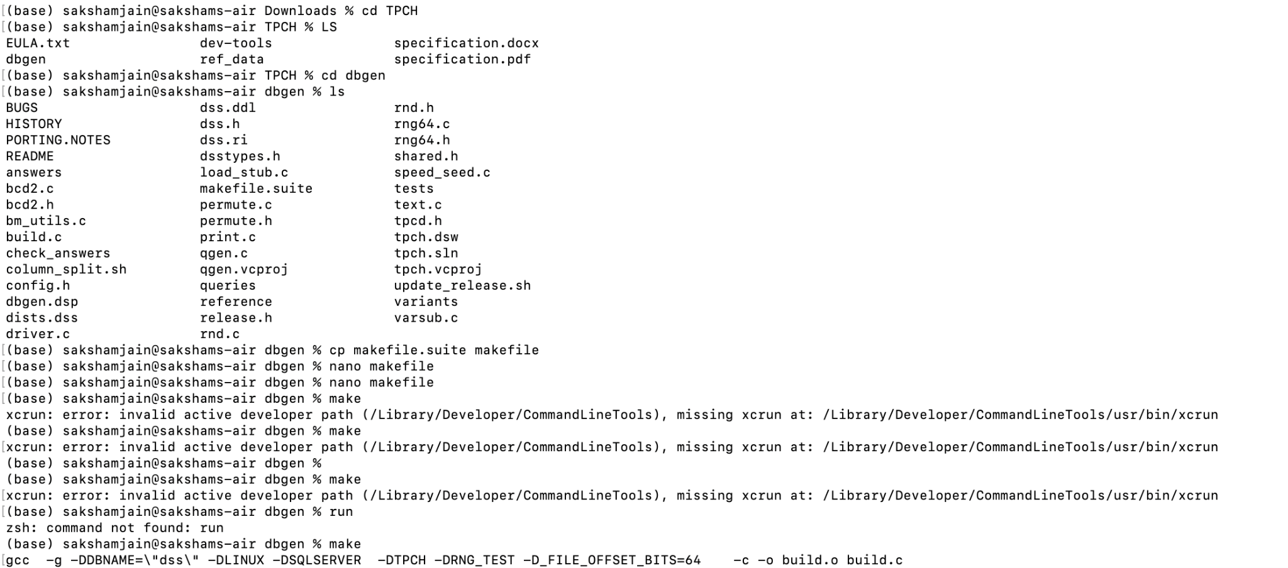

Step 10 : As you can see, the command gets executed as shown below.

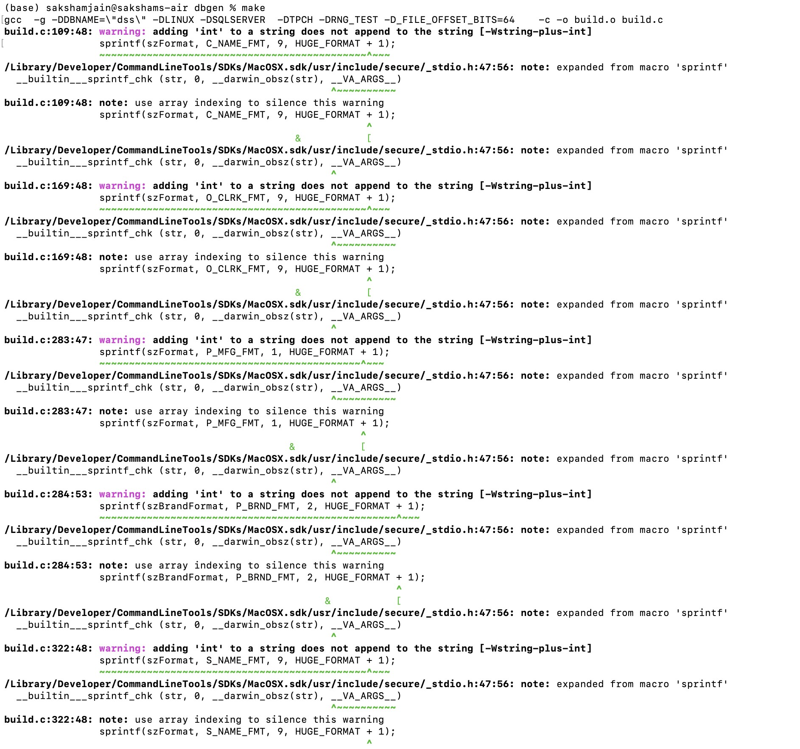

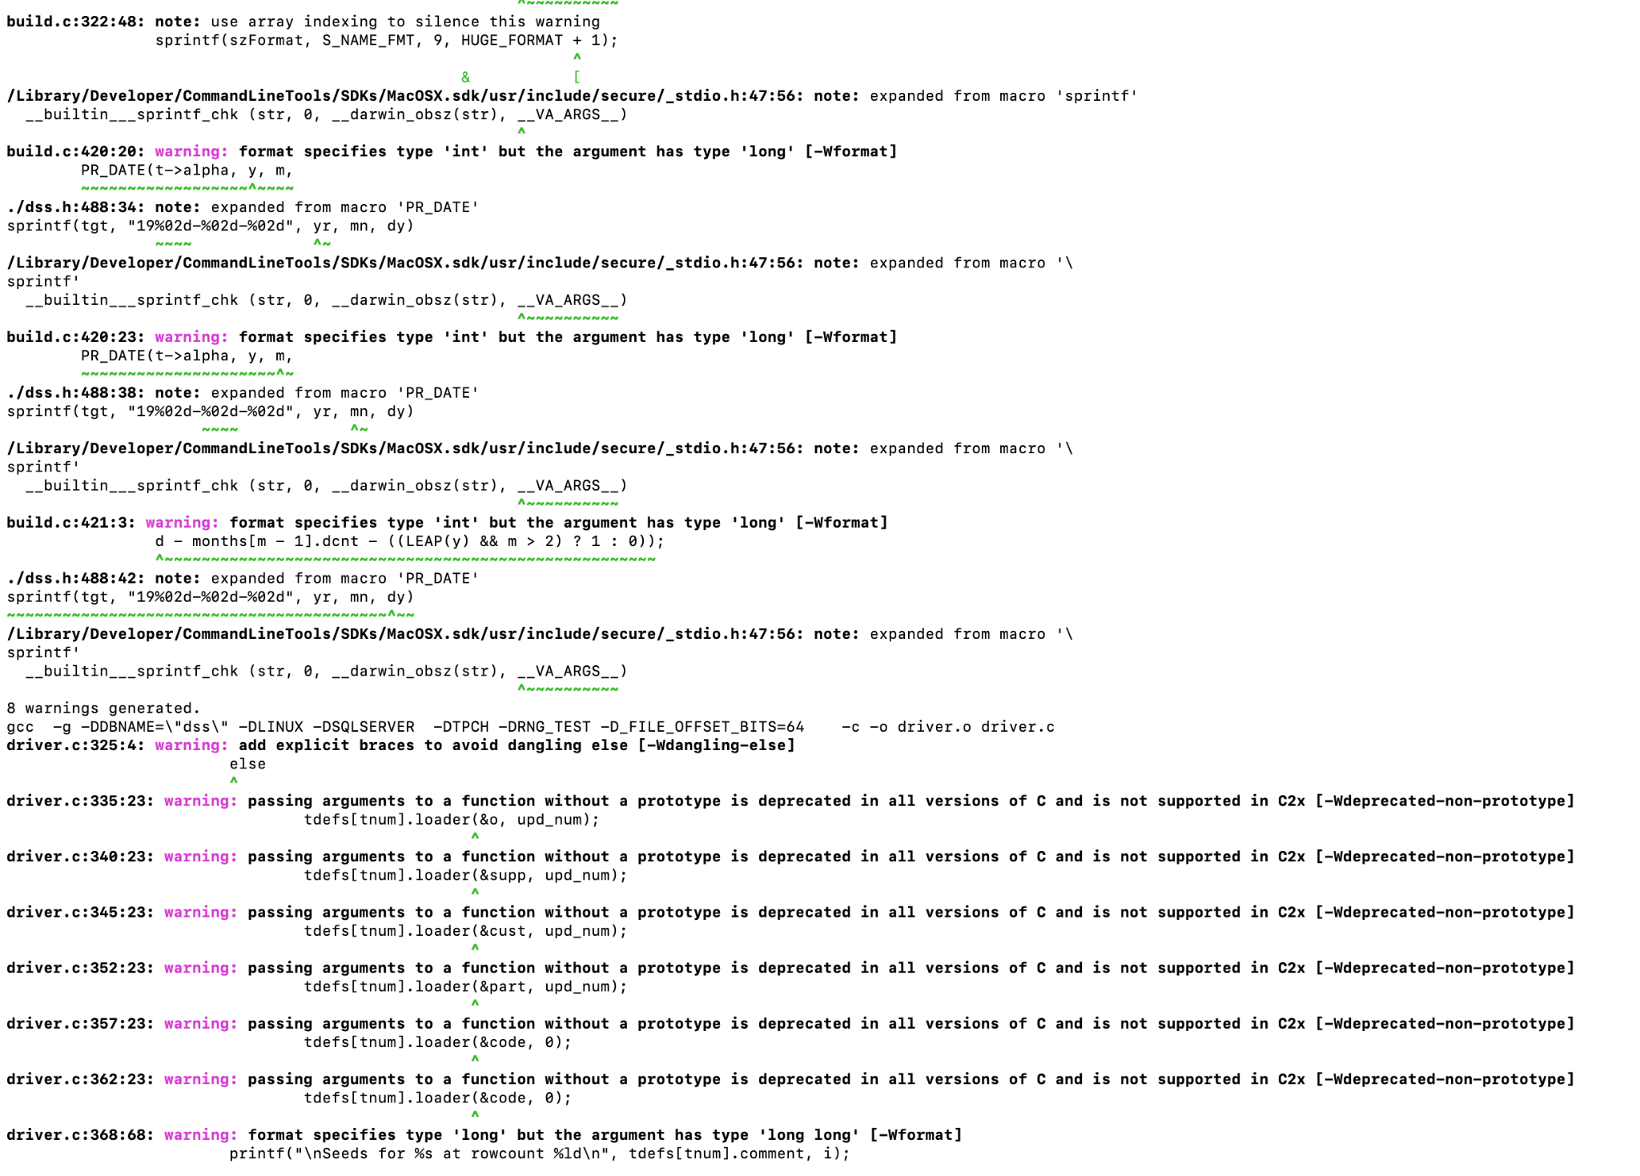

Step 11 : We get some **errors**, so we make changes in file ‘bm_utils.c’ .

Step 12 : We get another error and hence we change machine.

We take another mac OS laptop and run the above steps again. Following the steps from 1 - 11.

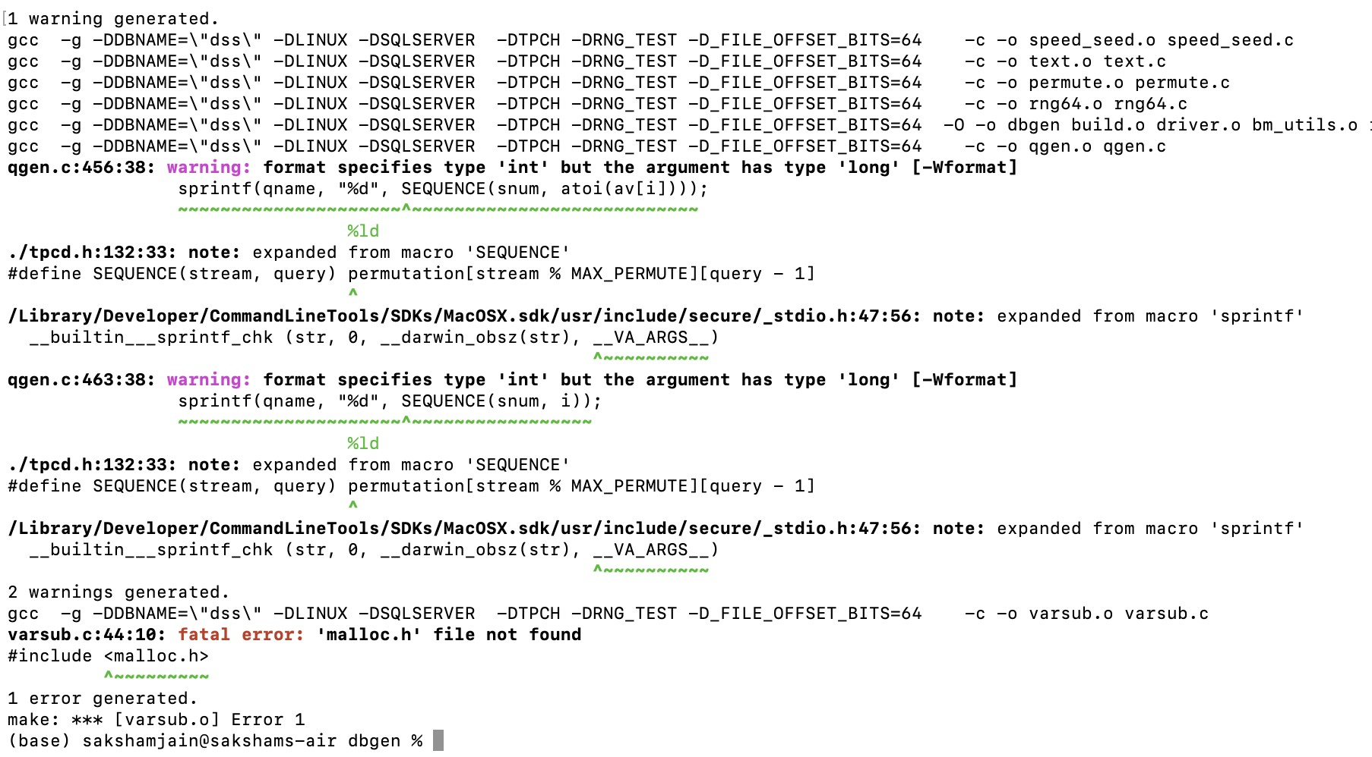

Step 13 : We have performed same steps in below new machine.

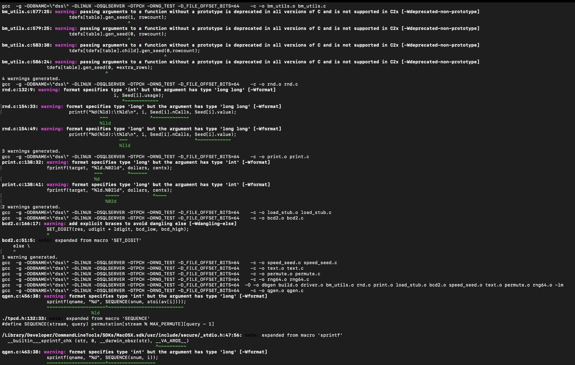

Step 13 : As you can see, now we are able to get the error resolved in 2nd machine. Now we see all files in TPC-H.

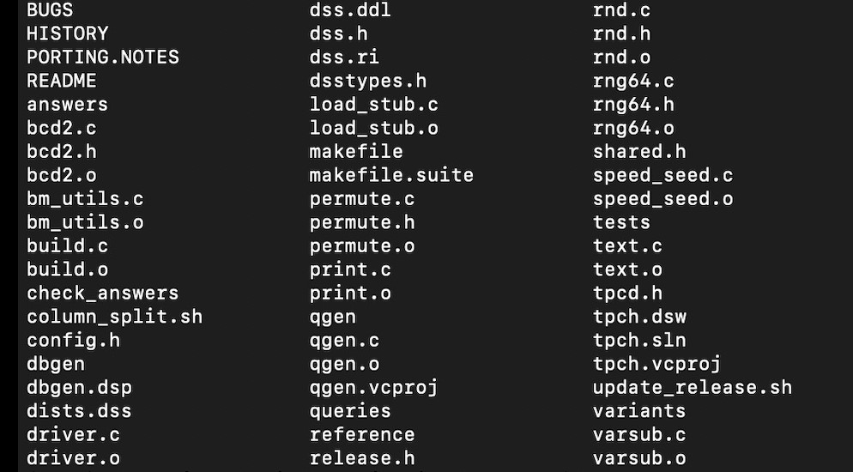

Step 14 : Now we use scale factor = 0.001. As you can see in below image, the TPCH population generator generates the files. Command to produce the data is

**./dbgen -s 0.001**





Step 15 : You can finally see the tables of TPC-H dataset. The tables are ending with “ .tbl” extension. In images below you can see 8 tables of dataset.

**Namely :**

1. **Supplier**
2. **Region**
3. **Partsupp**
4. **Part**
5. **Orders**
6. **Nation**
7. **Lineitem**
8. **Customers**

Now that we have got our tables. Let’s export the data to mysql server and create the 8 tables in mysql.

Step 1 : We got the required 8 tables, now convert these files to cvs format so that we can load those files directly in the MYSQL. We have used **https://dev.mysql.com/doc/heatwave/en/mys-hw-tpchquickstart-create-database-import.html** to get the sample tables.

Step 2 : By providing the .csv table file we can load the entire data. Use the following code

LOAD DATA INFILE

‘/Users/sakshamjain/Downloads/TPC_H_V3.0.1/dbgen/customer.csv’ INTO TABLE customer

FIELDS TERMINATED BY ‘|’ ENCLOSED BY ‘“’

LINES TERMINATED BY ‘\n’

Step 3 : Generate Output. As you can see the output of our create tables.

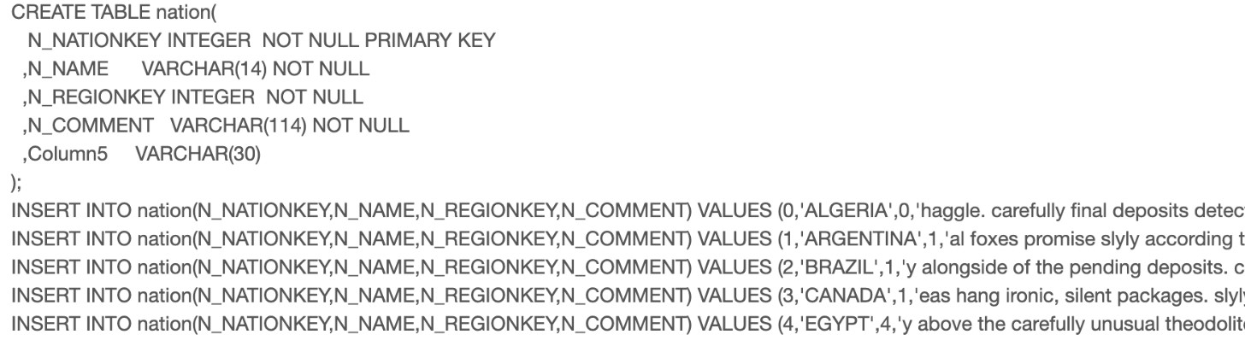

So, we have successfully installed TPC-H tools and loaded it into SQL. Now the data set is ready to use.

CREATE TABLE **nation** ( N_NATIONKEY INTEGER primary key, N_NAME

CHAR(25) NOT NULL, N_REGIONKEY INTEGER NOT NULL, N_COMMENT

VARCHAR(152));

CREATE TABLE **region** ( R_REGIONKEY INTEGER primary key, R_NAME

CHAR(25) NOT NULL, R_COMMENT VARCHAR(152));

CREATE TABLE **part** ( P_PARTKEY INTEGER primary key, P_NAME

VARCHAR(55) NOT NULL, P_MFGR CHAR(25) NOT NULL, P_BRAND CHAR(10)

NOT NULL, P_TYPE VARCHAR(25) NOT NULL, P_SIZE INTEGER NOT NULL,

P_CONTAINER CHAR(10) NOT NULL, P_RETAILPRICE DECIMAL(15,2) NOT

NULL, P_COMMENT VARCHAR(23) NOT NULL );

CREATE TABLE **supplier** ( S_SUPPKEY INTEGER primary key, S_NAME

CHAR(25) NOT NULL, S_ADDRESS VARCHAR(40) NOT NULL, S_NATIONKEY

INTEGER NOT NULL, S_PHONE CHAR(15) NOT NULL, S_ACCTBAL

DECIMAL(15,2) NOT NULL, S_COMMENT VARCHAR(101) NOT NULL);

CREATE TABLE **partsupp** ( PS_PARTKEY INTEGER NOT NULL, PS_SUPPKEY

INTEGER NOT NULL, PS_AVAILQTY INTEGER NOT NULL, PS_SUPPLYCOST DECIMAL(15,2) NOT NULL, PS_COMMENT VARCHAR(199) NOT NULL, primary key (ps_partkey, ps_suppkey) );

CREATE TABLE **customer** ( C_CUSTKEY INTEGER primary key, C_NAME

VARCHAR(25) NOT NULL, C_ADDRESS VARCHAR(40) NOT NULL,

C_NATIONKEY INTEGER NOT NULL, C_PHONE CHAR(15) NOT NULL,

C_ACCTBAL DECIMAL(15,2) NOT NULL, C_MKTSEGMENT CHAR(10) NOT

NULL, C_COMMENT VARCHAR(117) NOT NULL);

CREATE TABLE **orders** ( O_ORDERKEY INTEGER primary key, O_CUSTKEY

INTEGER NOT NULL, O_ORDERSTATUS CHAR(1) NOT NULL, O_TOTALPRICE

DECIMAL(15,2) NOT NULL, O_ORDERDATE DATE NOT NULL,

O_ORDERPRIORITY CHAR(15) NOT NULL, O_CLERK CHAR(15) NOT NULL,

O_SHIPPRIORITY INTEGER NOT NULL, O_COMMENT VARCHAR(79) NOT NULL);

CREATE TABLE **lineitem** ( L_ORDERKEY INTEGER NOT NULL, L_PARTKEY

INTEGER NOT NULL, L_SUPPKEY INTEGER NOT NULL, L_LINENUMBER

INTEGER NOT NULL, L_QUANTITY DECIMAL(15,2) NOT NULL,

L_EXTENDEDPRICE DECIMAL(15,2) NOT NULL, L_DISCOUNT DECIMAL(15,2)

NOT NULL, L_TAX DECIMAL(15,2) NOT NULL, L_RETURNFLAG CHAR(1) NOT

NULL, L_LINESTATUS CHAR(1) NOT NULL, L_SHIPDATE DATE NOT NULL,

L_COMMITDATE DATE NOT NULL, L_RECEIPTDATE DATE NOT NULL,

L_SHIPINSTRUCT CHAR(25) NOT NULL, L_SHIPMODE CHAR(10) NOT NULL, L_COMMENT VARCHAR(44) NOT NULL, primary key(L_ORDERKEY,L_LINENUMBER));

|  |  |  |
| --- | --- | --- |
| Table Name | Primary Key | Foreign Key |
| nation | N_NATIONKEY | N_REGIONKEY |
| region | R_REGIONKEY |  |
| part | P_PARTKEY |  |

|  |  |  |
| --- | --- | --- |
| supplier | S_SUPPKEY | S_NATIONKEY |
| partsupp | PS_PARTKEY, PS_SUPPKEY |  |
| customer | C_CUSTKEY | C_NATIONKEY |
| orders | O_ORDERKEY | O_CUSTKEY |
| lineitem | L_ORDERKEY,L_LINENUMBER | L_PARTKEY,L_SUPPKEY |

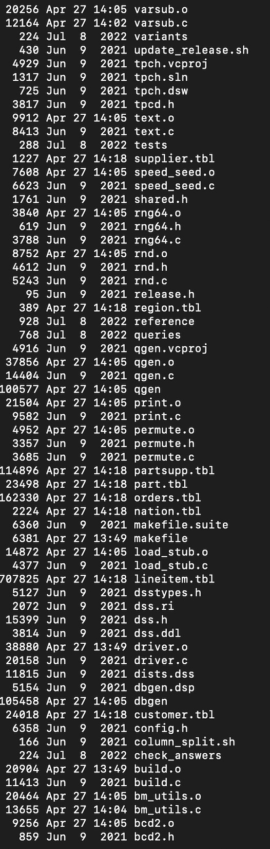

**Part B:**

**A special query: count the number of rows in each table of TPCH. You must provide the command and screenshot of the output of the command in the answer sheet. If you are not able to generate data at scale_factor =0.001, then the answer to this query will be wrong. And if the answer to this query is wrong, then the answers to the following query will also be wrong, since you have not generated the data correctly. You do not need to write a relational algebra expression for this query. B2. How many “part_key” are produced by “nationkey=5” and “7” or n_name= India for each P_brand?**

**B3. How many items are delivered “DELIVER IN PERSON” or “TAKE BACK RETURN” between “1994-01-23” and “1996-02-1?”**

**Question 5 Perform the following queries using SQL:**

**5.1 Create view account_loan which has 3 columns: account_id, number of loans, total sum of loans. 682 rows)**

CREATE VIEW account_loan AS

SELECT

l.account_id,

COUNT(l.id) AS num_loans,

SUM(l.amount) AS total_sum_loans

FROM

Loans l

GROUP BY

l.account_id;

Select * from account_loan;

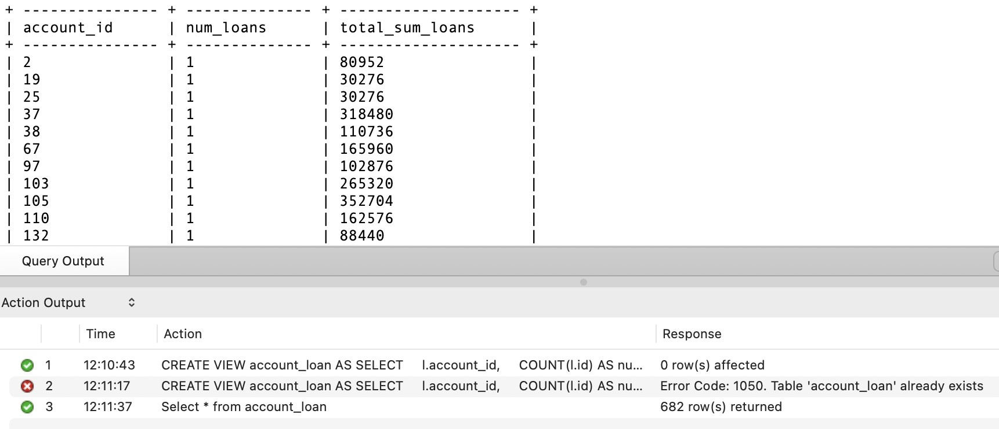

**5.2 Create view account_order which has 3 columns: account_id, number of orders, total sum orders. (3758 rows)**

CREATE VIEW account_order AS

SELECT

o.account_id,

COUNT(o.id) AS num_orders,

**o**

SUM(o.amount) AS total_sum_orders

FROM

Orders o

GROUP BY

o.account_id;

Select * from account_order;

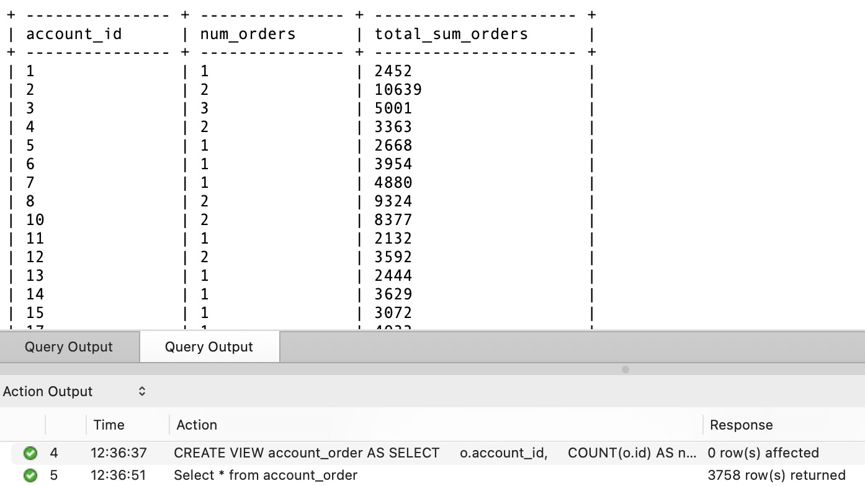

**5.3 Create view account_trans which has 3 columns: account_id, number of transactions, total sum of transactions. (4500 rows)**

CREATE VIEW account_trans AS

SELECT

t.account_id,

COUNT(t.id) AS num_transactions,

SUM(t.amount) AS total_sum_transactions

FROM

Transactions t

GROUP BY

t.account_id;

Select * from account_trans;

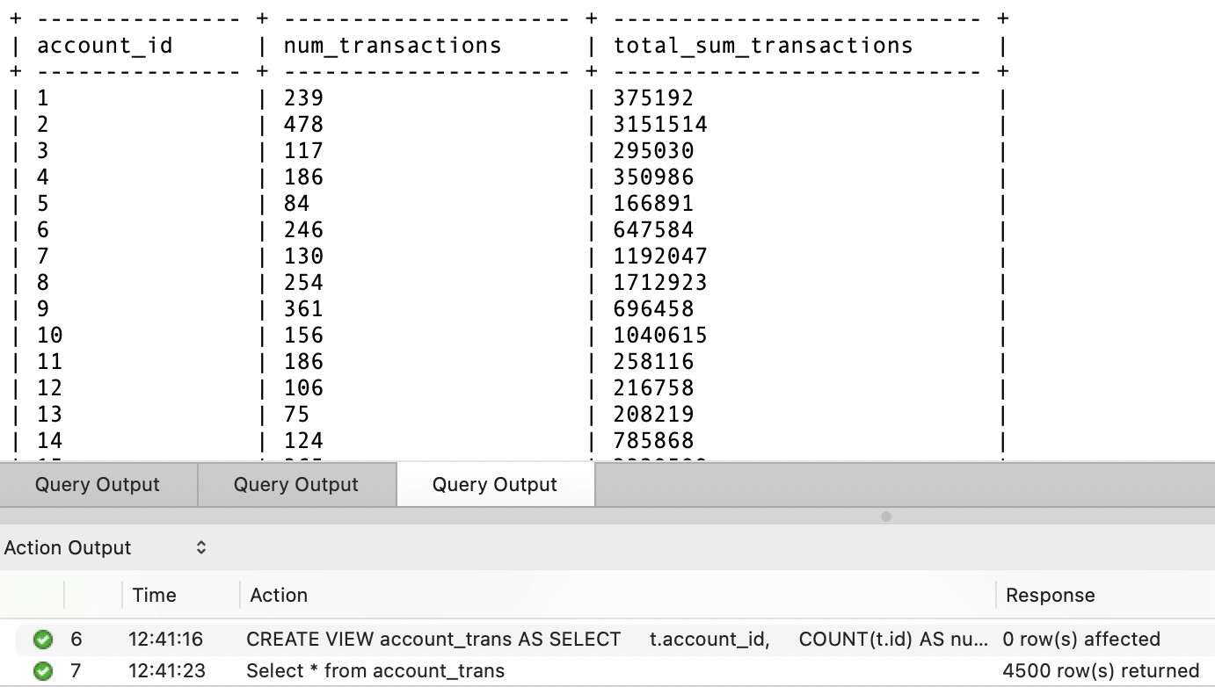

**5.4 Create view account_loan_order_trans which provides the number of loans, order, and transactions for each account along with the total amounts of each. (7576 rows) (Hint: use previous 3 views)**

CREATE VIEW account_loan_order_trans AS

SELECT

a.account_id,

COALESCE(al.num_loans, 0) AS num_loans,

COALESCE(al.total_sum_loans, 0) AS total_sum_loans,

COALESCE(ao.num_orders, 0) AS num_orders,

COALESCE(ao.total_sum_orders, 0) AS total_sum_orders, COALESCE(at.num_transactions, 0) AS num_transactions,

COALESCE(at.total_sum_transactions, 0) AS total_sum_transactions

FROM

Accounts a

LEFT JOIN

account_loan al ON a.id = al.account_id

LEFT JOIN

account_order ao ON a.id = ao.account_id

LEFT JOIN

account_trans at ON a.id = at.account_id;

Select * from account_loan_order_trans;

**5.5 Create a view district_stats where each row stores district id, district name, stat_type ( account or clients), count of the stat in district (# of accounts or # of clients), percentage of stat (# of accounts/# of clients / district population). (154 rows) (Percentage should be in percent form not decimal i.e., multiply by 100)**

CREATE VIEW district_stats AS

SELECT

d.id AS district_id,

d.name AS district_name,

'account' AS stat_type,

COALESCE(COUNT(DISTINCT a.id), 0) AS count_stat,

COALESCE((COUNT(DISTINCT a.id) / NULLIF(COUNT(DISTINCT c.id), 0)) * 100, 0) AS percentage_stat

FROM

Accounts a

JOIN

Districts d ON a.district_id = d.id

JOIN

Clients c ON a.district_id = c.district_id

GROUP BY

d.id, d.name

UNION ALL

SELECT

d.id AS district_id,

d.name AS district_name,

'client' AS stat_type,

COALESCE(COUNT(DISTINCT c.id), 0) AS count_stat,

COALESCE((COUNT(DISTINCT c.id) / NULLIF(COUNT(DISTINCT d.population), 0)) * 100, 0) AS percentage_stat

FROM

Clients c

JOIN

Districts d ON c.district_id = d.id

GROUP BY

d.id, d.name;

Select * from district_stats;

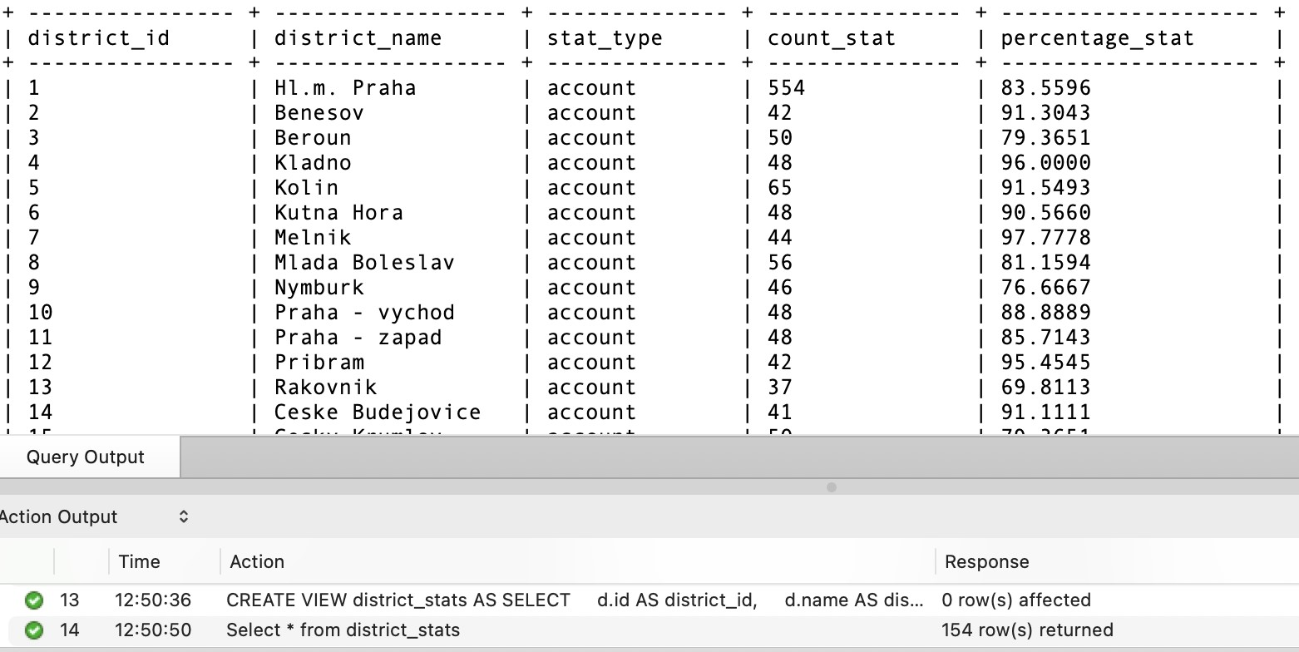

**5.6 Create view account_stats with 5 columns: account_id, type (loan/order/transaction), count of type, total amount of type, avg amount of type. One column for each account type pair. (8940 rows)**

CREATE VIEW account_stats AS

SELECT

a.id AS account_id,

'loan' AS type,

COALESCE(COUNT(l.id), 0) AS count_type,

COALESCE(SUM(l.amount), 0) AS total_amount_type,

COALESCE(AVG(l.amount), 0) AS avg_amount_type

FROM

Loans l

JOIN

Accounts a ON l.account_id = a.id

GROUP BY

a.id

UNION ALL

SELECT

a.id AS account_id,

'order' AS type,

COALESCE(COUNT(o.id), 0) AS count_type,

COALESCE(SUM(o.amount), 0) AS total_amount_type,

COALESCE(AVG(o.amount), 0) AS avg_amount_type

FROM

Orders o

JOIN

Accounts a ON o.account_id = a.id

GROUP BY

a.id

UNION ALL

SELECT

a.id AS account_id, 'transaction' AS type,

COALESCE(COUNT(t.id), 0) AS count_type,

COALESCE(SUM(t.amount), 0) AS total_amount_type,

COALESCE(AVG(t.amount), 0) AS avg_amount_type

FROM

Transactions t

JOIN

Accounts a ON t.account_id = a.id

GROUP BY

a.id;

Select * from account_stats;

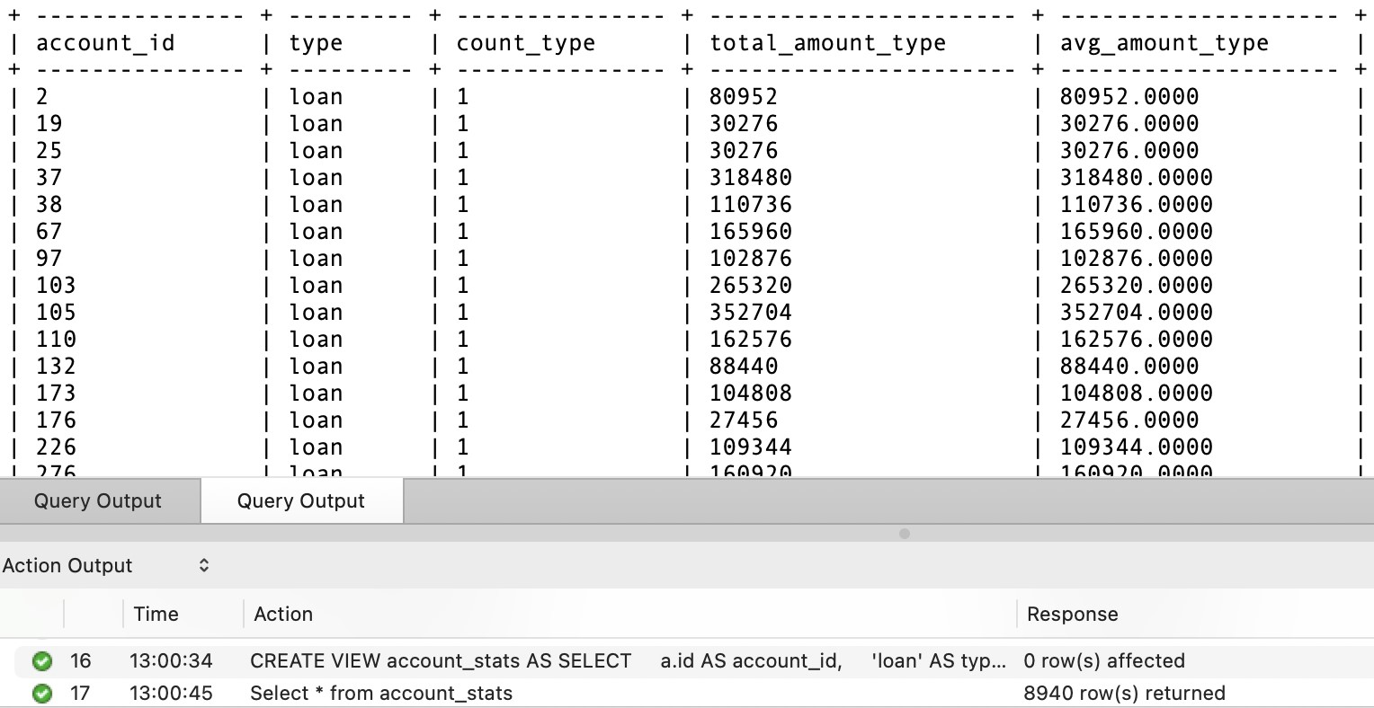

**5.7 ) Create a trigger on transactions that executes before insert and stores the transaction in a table called flagged_transactions (columns same as transactions) if the transaction amount is more than 2 times the average transaction amount for the account. Then insert the following rows and display all rows of flagged_transactions.**

-- Create the flagged_transactions table if it doesn't exist

CREATE TABLE IF NOT EXISTS flagged_transactions ( id INT PRIMARY KEY AUTO_INCREMENT,

account_id INT, date DATE, type VARCHAR(255), operation VARCHAR(255), amount DECIMAL(10, 2), balance DECIMAL(10, 2), k_symbol VARCHAR(255), bank VARCHAR(255), account VARCHAR(255)

);

-- Create the trigger on Transactions table

DELIMITER //

CREATE TRIGGER trg_transactions_before_insert

BEFORE INSERT ON transactions FOR EACH ROW

BEGIN

DECLARE avg_amount DECIMAL(10, 2);

-- Calculate the average transaction amount for the account

SELECT AVG(amount) INTO avg_amount

FROM transactions

WHERE account_id = NEW.account_id;

-- Check if the transaction amount is more than 2 times the average IF NEW.amount > 2 * avg_amount THEN

-- Insert the flagged transaction into flagged_transactions table

INSERT INTO flagged_transactions (account_id, date, type, operation, amount, balance, k_symbol, bank, account)

VALUES (NEW.account_id, NEW.date, NEW.type, NEW.operation, NEW.amount,

NEW.balance, NEW.k_symbol, NEW.bank, NEW.account); END IF;

END;

//

DELIMITER ;

INSERT INTO TRANSACTIONS VALUES(4000005, 1, '1998-12-31', "VYDAJ", "VYBER", 1000,20000 "UROK", null, null);

INSERT INTO TRANSACTIONS VALUES(4000006, 2, '1995-12-31', "VYDAJ", "VYBER", 3000,20000 "UROK", null, null);

INSERT INTO TRANSACTIONS VALUES(4000007, 4, '1997-1-20', "VYDAJ", "VYBER", 4000, 20000, "UROK", null, null);

INSERT INTO TRANSACTIONS VALUES(4000008, 6, '1998-5-12', "PRIJEM", "VYBER", 3000,20000, "UROK", null, null);

INSERT INTO TRANSACTIONS VALUES(4000009, 8, '1994-9-22', "PRIJEM", "VYBER", 500, 20000, "UROK", null, null);

INSERT INTO TRANSACTIONS VALUES(4000010, 9, '1999-6- 15', "PRIJEM", "VYBER", 4500, 20000 "UROK", null, null);

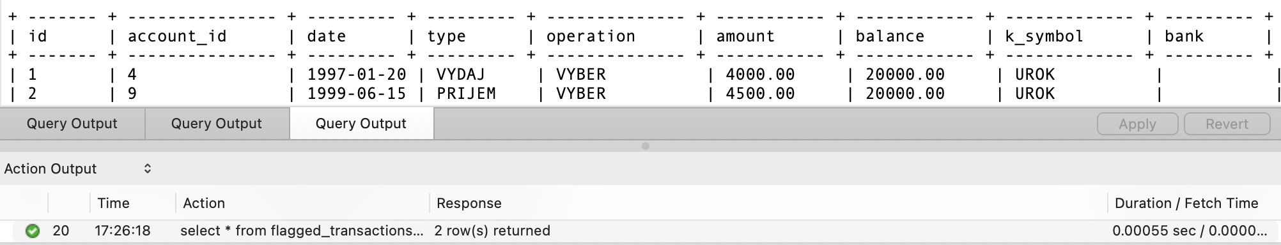

**5.8 ) Create a table called credit_in_cash with 3 columns: id (stores transaction id), account_id, amount. Create a trigger called cash_credit_log that logs the id, account id, and amount of all cash credit transactions (operation = VKLAD). Run the following commands and then display credit_in_cash. (5 rows)**

-- Create the credit_in_cash table if it doesn't exist

CREATE TABLE IF NOT EXISTS credit_in_cash ( id INT PRIMARY KEY AUTO_INCREMENT,

transaction_id INT, account_id INT,

amount DECIMAL(10, 2)

);

-- Create the trigger on Transactions table

DELIMITER //

CREATE TRIGGER trg_cash_credit_log

AFTER INSERT ON transactions FOR EACH ROW

BEGIN

-- Check if the transaction is a cash credit transaction (operation = 'VKLAD') IF NEW.operation = 'VKLAD' THEN

-- Insert the transaction id, account id, and amount into credit_in_cash table

INSERT INTO credit_in_cash (transaction_id, account_id, amount)

VALUES (NEW.id, NEW.account_id, NEW.amount); END IF;

END;

//

DELIMITER ;

INSERT INTO TRANSACTIONS VALUES(4000011, 5, '1998-12-31', "VYDAJ", "VKLAD", 1000,20000,

INSERT INTO TRANSACTIONS VALUES(4000012, 7, '1995-12-31', "VYDAJ", "VKLAD", 200,20000, "

INSERT INTO TRANSACTIONS VALUES(4000013, 11, '1996-1-31', "VYDAJ", "VKLAD", 100,20000, "

INSERT INTO TRANSACTIONS VALUES(4000014, 13, '1998-5-12', "VYDAJ", "VKLAD", 1500,20000,

INSERT INTO TRANSACTIONS VALUES(4000015, 14, '1999-6-15', "VYDAJ", "VKLAD", 600,20000, "

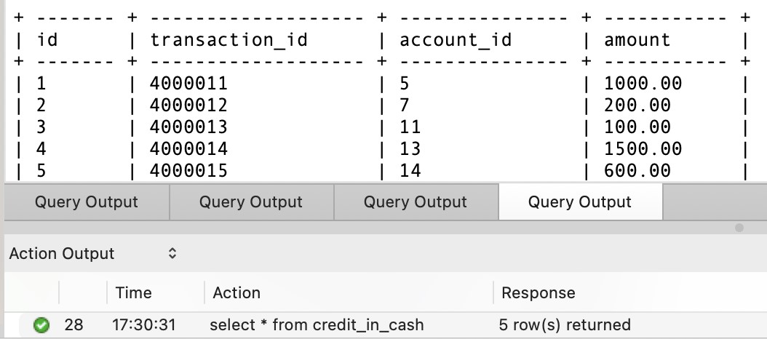

**5.9) Create a table called credit_in_cash_violation with 4 columns: id (stores transaction id), account_id, amount, current_balance (current cash credit total for account). Create a trigger called valid_cash_credit that inserts the cash credit transaction (operation = ‘VYKLAD’) into transactions only if the total amount of cash credit transactions (including new) for the account in credit_in_cash is less than or equal to 2000. If not, then insert the available balance as cash credit and insert the new amount and current total along with transaction id and account id into credit_in_cash_violation. (Eg. if past transaction sum is 1700 and new transaction is 500, only insert 300 as account cannot exceed limit and insert 1700 as current_balance and 500 as a). Insert the following rows and display credit_in_cash_violation. (1 row)**

-- Create the credit_in_cash_violation table if it doesn't exist

CREATE TABLE IF NOT EXISTS credit_in_cash_violation ( id INT PRIMARY KEY AUTO_INCREMENT,

account_id INT, amount DECIMAL(10, 2), current_balance DECIMAL(10, 2)

);

-- Create the trigger on credit_in_cash table

DELIMITER //

CREATE TRIGGER trg_valid_cash_credit

BEFORE INSERT ON credit_in_cash FOR EACH ROW

BEGIN

DECLARE total_amount DECIMAL(10, 2);

DECLARE available_balance DECIMAL(10, 2);

-- Get the total amount of cash credit transactions (including new) for the account

SELECT COALESCE(SUM(amount), 0) INTO total_amount

FROM credit_in_cash

WHERE account_id = NEW.account_id;

-- If total amount exceeds 2000, insert available balance as cash credit in transactions table

IF total_amount + NEW.amount > 2000 THEN

-- Get the available balance

SELECT (2000 - total_amount) INTO available_balance;

-- Insert the available balance as cash credit transaction into transactions table

INSERT INTO transactions (account_id, date, type, operation, amount, balance, k_symbol, bank, account)

VALUES (NEW.account_id, CURDATE(), 'type1', 'VKLAD', available_balance,

(SELECT balance FROM accounts WHERE id = NEW.account_id), 'k_symbol1',

'bank1', 'account1');

-- Insert the new amount and current total into credit_in_cash_violation table

INSERT INTO credit_in_cash_violation (account_id, amount, current_balance) VALUES (NEW.account_id, NEW.amount, total_amount + NEW.amount);

-- Set the NEW.amount to 0 to prevent insertion of cash credit into credit_in_cash table

SET NEW.amount = 0;

ELSE

-- Insert the cash credit transaction into transactions table

INSERT INTO transactions (account_id, date, type, operation, amount, balance, k_symbol, bank, account)

VALUES (NEW.account_id, CURDATE(), 'type1', 'VKLAD', NEW.amount, (SELECT balance FROM accounts WHERE id = NEW.account_id), 'k_symbol1', 'bank1',

'account1');

END IF;

END;

//

DELIMITER ;

INSERT INTO TRANSACTIONS VALUES(4000016, 5, '1998-12-31', "VYDAJ",

"VKLAD", 1500,

20000, "UROK", null, null);

INSERT INTO TRANSACTIONS VALUES(4000017, 7, '1995-12-31', "VYDAJ",

"VKLAD", 300,

20000, "UROK", null, null);

INSERT INTO TRANSACTIONS VALUES(4000018, 11, '1996-1-31', "VYDAJ",

"VKLAD", 100,

20000, "UROK", null, null);

INSERT INTO TRANSACTIONS VALUES(4000019, 17, '1998-5-12', "VYDAJ",

"VKLAD", 1500,

20000, "UROK", null, null);

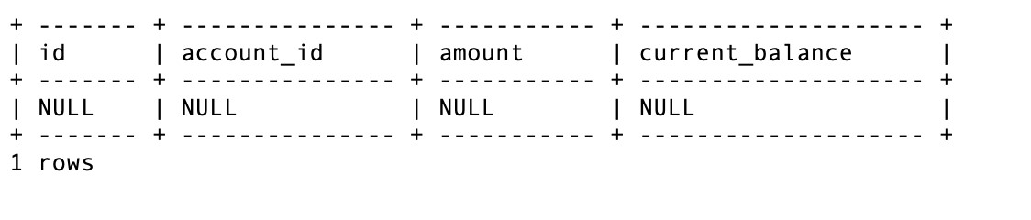

**5.10 ) Create a table loan_balance with 5 columns: id (loan id), account_id, amount, amount_paid, amount_left. Populate the table by adding one row for every row in loans. Copy the id, account_id and amount, set amount_paid to 0 and amount_left to amount. Create a trigger that adjusts the loan_balance every time a loan payment order is made (order.k_symbol = ‘UVER’) by increasing the amount paid and decreasing amount left. Insert the following rows in orders and display all rows from loan_balance. (682 rows, 4 changed)**

-- Create the loan_balance table

CREATE TABLE loan_balance ( id INT PRIMARY KEY,

account_id INT, amount DECIMAL(10,2), amount_paid DECIMAL(10,2), amount_left DECIMAL(10,2)

);

-- Populate loan_balance table with data from Loans table

INSERT INTO loan_balance (id, account_id, amount, amount_paid, amount_left)

SELECT id, account_id, amount, 0, amount FROM Loans;

-- Create a trigger on Orders table

DELIMITER //

CREATE TRIGGER update_loan_balance_trigger

AFTER INSERT ON Orders FOR EACH ROW

BEGIN

-- Check if the inserted order is a loan payment order with k_symbol = 'UVER' IF NEW.k_symbol = 'UVER' THEN

-- Update the loan_balance table with the amount paid and amount left

UPDATE loan_balance

SET amount_paid = amount_paid + NEW.amount, amount_left = amount_left - NEW.amount

WHERE id = NEW.account_id;

END IF;

END;

//

DELIMITER ;

INSERT INTO ORDERS VALUES (1, 2, "AB", 12345678, 5000 , 'UVER');

INSERT INTO ORDERS VALUES (2, 25, "XY", 47299182, 100 , 'UVER');

INSERT INTO ORDERS VALUES (3, 67, "FJ", 98348264, 3000, 'UVER');

Select * from loan_balance

